Name / Student Number: Vasukumar Patel [041153940]
Lab Professor: Teddy Yap
Assignment – 1 in R Language

PART – A

- Describe what is happening to the data as a general trend in the second and third column.
- Second column: The numbers keep getting smaller and smaller. After some point, they are too small for the computer to store, so they become 0.
- Third column: The numbers keep getting bigger and bigger. After some point, they are too big for the computer to store, so they become Inf (infinity).
- The table shows that a computer can only store numbers within a limited range. Very small numbers turn into 0, and very large numbers turn into Inf.

- What is happening when the second column goes to 0? Provide an explanation why.
- The numbers in the second column keep getting smaller and smaller. At some point, they become smaller than the smallest number the computer can represent. When this happens, the computer can no longer store the value accurately, so it rounds it down to 0.
- This happens because computers use double-precision floating-point numbers, which have a minimum limit (called double.xmin). Any number smaller than this limit is stored as 0.

- What is happening when the third column goes to INF? Provide an explanation why.
- The numbers in the third column keep getting bigger and bigger. After some point, the numbers become larger than the biggest number the computer can store. When this limit is passed, the computer cannot represent the value anymore, so it shows Inf, which means infinity.
- This happens because double-precision numbers have a maximum limit (called double.xmax). Any value larger than this limit is stored as Inf.

- Explain what is the value for double.xmin for your machine, as well as what is the definition of double.xmin?

- On my machine, the value of double.xmin is 2.225074e-308.
- double.xmin is defined as the smallest positive number that can be represented using double-precision floating-point arithmetic on the computer.
- Any number smaller than this value cannot be stored accurately and is rounded down to 0, which causes underflow.

- Locate the value in the second column that is closest to your double.xmin. Explain what is happening after that line.

- The number in the second column that is closest to double.xmin is found around line 1021/1022 and these are 2.2250738585072e-308 and 1.1125369292536e-308
- Up to this line, the computer is still able to store the values.
- After this line, the numbers become too small for the computer to handle.
- When this happens, underflow occurs, meaning the computer cannot save the values correctly and they are stored as 0.

PART – B
- Code :

n <- 1:10
factorial_n <- factorial(n)
approximation <- ( (n / exp(1))^n * sqrt(2*pi*n) )
absolute_error <- abs(factorial_n - approximation)
percent_relative_error <- (absolute_error/factorial_n) * 100

df <- data.frame(
n = n,
factorial_n = signif(factorial_n,2),
Approximation = signif(approximation, 2),
absolute_error = signif(absolute_error, 2),
percent_relative_error = signif(percent_relative_error, 2)
)

df

- Describe, in general, what is happening to the data in the third column called Approximation.
- The Approximation column shows an estimate of the factorial. For small numbers, the estimate can be a little off, but as the numbers get bigger, the estimate becomes closer to the actual value in terms of percentage, even though the difference in actual numbers (absolute error) may increase.

- Describe, in general, what is happening to the data in the fourth column called Absolute Error.
- The Absolute Error column shows the difference between the approximation and the actual factorial. As the numbers get bigger, the absolute error increases because factorials grow very fast.

- Describe what is happening to the accuracy of the approximation as n increases? Provide evidence for your description.
- As n increases, the accuracy of the approximation improves.
- at 7.80% for n=1n = 1n=1 and drops to 0.83% for n=10 n = 10n=10. This means that, even though the absolute difference grows, the approximation is closer to the true factorial in relative terms for larger numbers.

PART – C
- Code :

data("mtcars")
mtcars
names(mtcars)
head(mtcars)
str(mtcars)
summary(mtcars)

mtcars$vs <- factor(mtcars$vs,
levels = c(0, 1),
labels = c("V-Shaped", "Straight"))
table(mtcars$vs)
head(mtcars)

plot( mtcars$mpg, mtcars$hp,
main = "Horsepower vs Miles Per Gallon",
xlab = "Miles Per Gallon",
ylab = "Horsepower" )

red_cars <- mtcars[ (mtcars$hp < 250 & mtcars$hp > 200) & mtcars$mpg < 13, ]
green_cars <- mtcars[mtcars$hp < 100 & mtcars$mpg > 30, ]

red_cars
green_cars

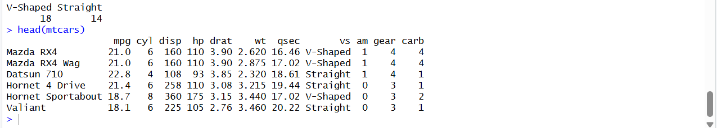

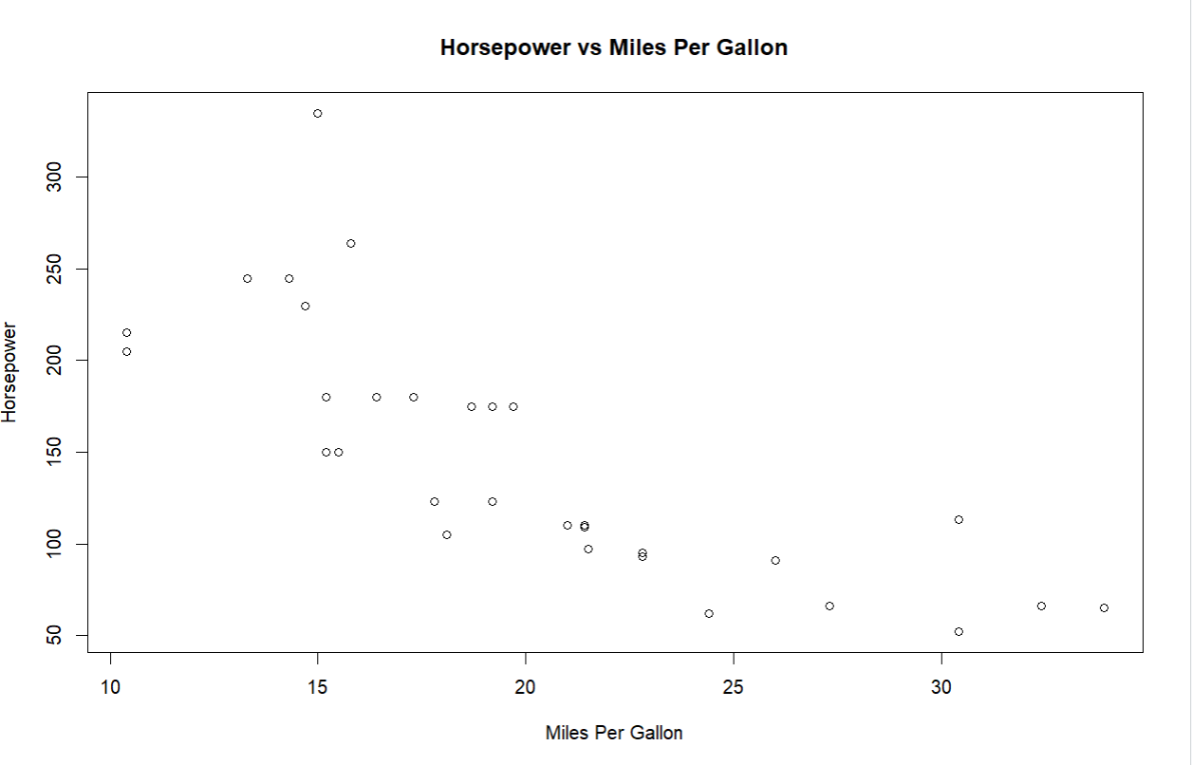

- Using your plotted data, explain what is meant by the term outliers.
- Outliers are data points which are very different from most of the other data. In the Horsepower vs Miles Per Gallon plot, the red and green cars are outliers because their horsepower and mileage are very far from the rest of the cars.

- Referring to your plotted data, what can be generalized about the data and the relationship between mpg and hp?
- Cars with more horsepower usually have lower mileage, and most cars are in the middle range, but some outliers are far from this trend.

